**Progress Report 1**

#### **Project Title**

C2LAP with Paula

#### **Project Timeline**

|  |  |  |  |
| --- | --- | --- | --- |
| **Start Date** | **End Date** | **Activity** | **Remarks** |
| 22nd Feb | | Problem Statement | **Finished.** Broad problem statements |
| 22nd Feb | 1st Mar | Data Exploration | **Finished.** Explore data provided |
| 1st Mar | 7th Mar | Data Cleaning &  Developing Problem Statement | Missing values, required data  More detailed problem statements |
| 7th Mar | 11th Mar | Developed Analytical Methodology | linear regression, clustering, association |
| Build & Execute Analytics Model |  |
| 12th Mar | 18th Mar | Generate Insight |  |
| Develop Concrete Action Plan | Recommendations |
| 19th Mar | 28th Mar | Generate Report & Slides |  |
| 22nd Mar | | Internal Review with Course Instructor | Report refinement after review |
| 29th Mar | | Submission of Report |  |
| 19 Apr | | Presentation of Report |  |

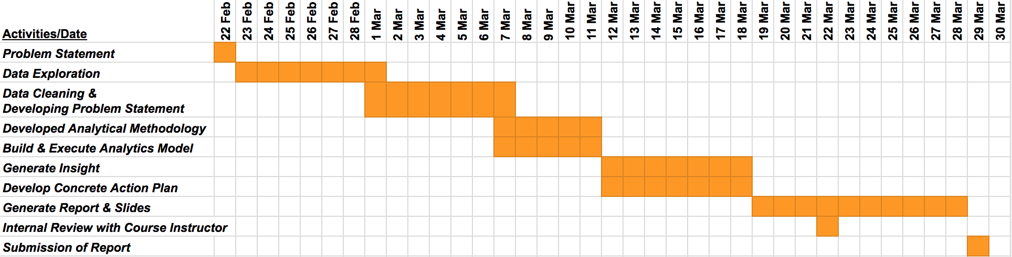

#### **Tasks Completed**

###### Problem Statement

How can we develop a sustainable customer journey and reduce operational cost to improve profit?

###### Data Exploration

|  |  |  |
| --- | --- | --- |
| **Names** | **Responsible Explorations** | **Data Source** |
| Chen Ziao | Customer Journey, SKU Association | API & Order Data |
| Lee Pei Shan | Product Line | Sales Data |
| Ng Ning Ting Vivian | Product Channel | Sales Data & Online Resource |
| Leonard | Sales & Inventory | Sales Data |